https://www.ebay.com/itm/3-7V-3000mAh-904260-Lithium-Polymer-Lipo-Li-ion-Rechargeable-Battery-USA-STOCK/173904251593?ssPageName=STRK%3AMEBIDX%3AIT&_trksid=p2057872.m2749.l2649

https://www.aliexpress.com/item/32880825587.html

https://www.dhgate.com/product/3-7v-3000mah-904260-lithium-polymer-lipo/447454248.html

- 100% brand new.
- High quality and high capacity!
- Built-in protection circuit PCM for prevent over charging or over discharging
- Size: 9mm(H)*42mm(W)*60mm(L)Rating: DC3.7V 3000mAh

Charging current: standard charging, fast charging: 1.0C: 0.5C
Standard charging method: 0.5C CC (constant current) charge to 4.25V,
then CV (constant voltage 4.2V) charge till charge current is less than or equal to 0.05C.
The maximum charge current: 1C
Maximum discharge current: 1C
Discharge cut-off voltage: 2.75V
The discharge temperature: -20 degrees C-+60 degrees C
Charging time: 3-7hrs (standard); 3hrs (fast)
Protection function: over charge, over discharge, over current, short circuit protection, over temperature protection It can be recharged repeatedly
Built-in protection circuit PCM for prevent over charging or over discharging.

Polymer Lithium Li-ion Battery Power Bank Application:
1 communication: cellular phone, web phone, interphone, Bluetooth earphone.
2.office devices: Notebook, PDA, portable electrograph, portable printer.
3.Video devices: GPS, digital camera, camcorder, portable DVD, portable television, MP3, MP4.
4.Portable exchange devices: POS, Handy, Fingerprint machine, portable stock machine.
5.Illuminate devices: miner lamp, searchlight.
6.Others: toys, models.

1xpcs 3.7V 3000mAh high capacity lithium li-polymer li ion rechargeable battery for MP3 MP4 GPS Navigation bluetooth power bank headset dvd Recorder camera...
Model:904260
Especially suitable for mobile phones, MID, PAD, LED, eye care instrument, game consoles, MP4, mobile power, POS, e-books, apple backup power, model aircraft, mobile power and other high-tech digital products.
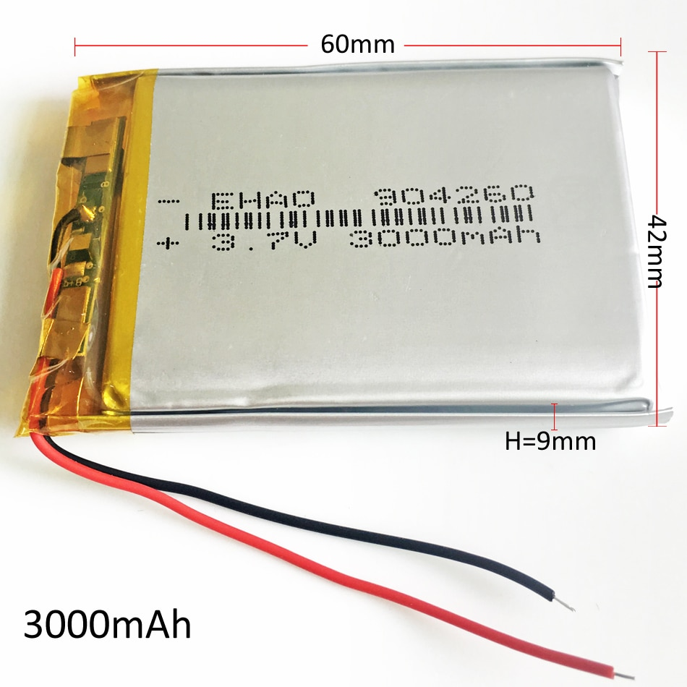
Features:
1> 100% brand new
2> High quality and high capacity!
3> Built-in protection circuit PCM for prevent over charging or over discharging
4> Size: 9mm(H)*42mm(W)*60mm(L)
5> Rating: DC3.7V 3000mAh
Nominal voltage: 3.7 V
Nominal capacity: 3000mAh, 1C discharge
Charging current: standard charging, fast charging: 1.0C: 0.5C
Standard charging method: 0.5C CC (constant current) charge to 4.25V, then CV (constant voltage 4.2V) charge till charge current is less than or equal to 0.05C
The maximum charge current: 1C
Maximum discharge current: 1C
Discharge cut-off voltage: 2.75V
The discharge temperature: -20 degrees C~+60 degrees C
Charging time: 3-5hrs (standard); 3hrs (fast)
Protection function: over charge, over discharge, over current, short circuit protection, over temperature protection

Package include:
1 x pcs 3.7v 3000mAh 904260 Lithium polymer li ion rechargeable battery. 9*42*60mm

